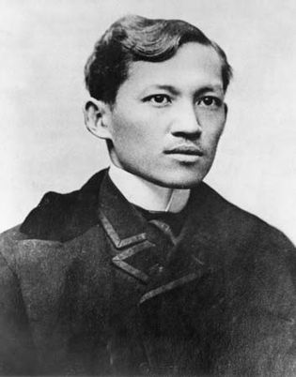

JOSE RIZAL, the national hero of the Philippines and pride of the Malayan race, was born on June 19, 1861, in the town of Calamba, Laguna. He was the seventh child in a family of 11 children (2 boys and 9 girls). Both his parents were educated and belonged to distinguished families.

Francisco Mercado Rizal, his hardworking father and "a model of fathers," was born in Bifñan, Laguna, while his mother was from Rizal. The highly accomplished and cultured Teodora Alonzo y Quintos, whom Rizal referred to as his "loving and prudent mother," was born in Meisic, Sta. Cruz, the Philippines. His mother taught him the alphabet when he was three years old, and even as he was learning to read and write, he began to express an interest in becoming an artist. He amazed his family and friends with his clay moldings and pencil drawings and sketches. His poem "Sa Aking Mga Kabota," which he wrote in Tagalog when he was eight years old, is about the love of one's native tongue. At the age of sixteen, he graduated from the Ateneo Municipal de Manila in 1877 with a Bachelor of Arts degree with an average of "excellent." That same year, he enrolled in the University of Santo Tomas to study Philosophy and Letters, and concurrently he completed courses at the Ateneo to become an expert assessor and surveyor. On March 21, 1877, he completed the latter course, and on May 21, 1878, he passed the surveyor's examination. However, due to his age of seventeen, he was not authorized to practice his profession until December 30, 1881.

He enrolled in the University of Santo Tomas to study medicine in 1878, but he was forced to drop out because he believed that the Dominican tutors there were discriminating against the Filipino students. He set sail for Spain on May 3, 1882, and enrolled at the Universidad Central de Madrid, where he completed his studies. On June 21, 1884, at the age of 23, he received his degree as a Licentiate in Medicine, and on June 19, 1885, at the age of 24, he received a "excellent" mark for his Philosophy and Letters course.

He was an expert swordsman and a good shot. In the hope of securing political and social reforms for his country and at the same time educate his countrymen, Rizal, the greatest apostle of Filipino nationalism, published, while in Europe, several works with highly nationalistic and revolutionary tendencies. In March 1887, his daring book, NOLI ME TANGERE, a satirical novel exposing the arrogance and despotism of the Spanish clergy, was published in Berlin, in 1890 he reprinted in Paris, Morga's SUCCESSOS DE LAS ISLAS FILIPINAS with his annotations to prove that the Filipinos had a civilization worthy to be proud of even long before the Spaniards set foot on Philippine soil, an September 18, 1891, EL FILIBUSTERISMO, his second novel and a sequel to the NOLI and more revolutionary and tragic than the latter, was

printed in Ghent.

When the Philippine Revolution started on August 26, 1896, his enemies lost no time in pressing him down. They were able to enlist witnesses that linked him with the revolt and these were never allowed to be confronted by him. Thus, from November 3, 1986, to the date of his arrest by Spanish authorities on charges of rebellion, sedition, and conspiracy. He is imprisoned in Fort Santiago in Manila. Then he's execution on December 30, 1896, Rizal endured a period of intense scrutiny and persecution by the Spanish authorities. Despite being primarily a man of letters and a proponent of peaceful reforms, his writings and intellectual influence were perceived as threats to the colonial order.

TimeLine

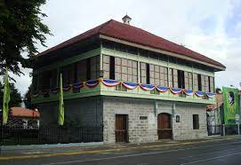

June 19, 1861: José Protasio Rizal Mercado y Alonso Realonda is born in Calamba, Laguna, Philippines.

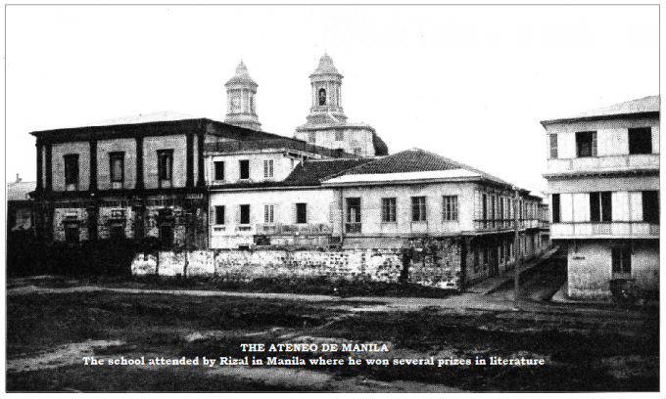

1872: Rizal enters the Ateneo Municipal de Manila, where he studies until 1877.

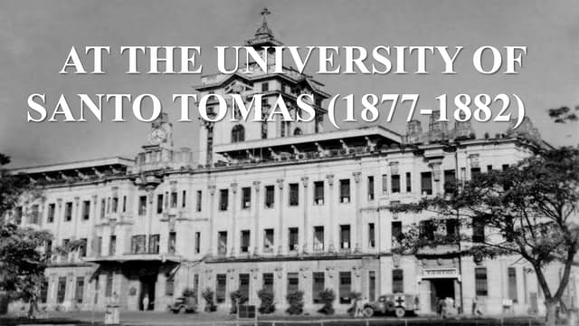

1877-1882: Rizal goes to the University of Santo Tomas to study medicine and later moves to Spain to continue his studies at the Universidad Central de Madrid.

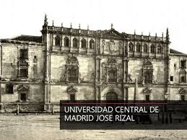

1882-1887: Rizal completes his degree in medicine and takes up further studies in philosophy and letters at the Central University of Madrid, where he also begins writing his first novel, "Noli Me Tangere."

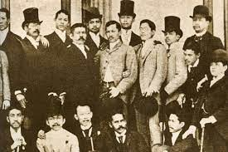

1887-1892: Rizal travels extensively throughout Europe, visiting France, Germany, Austria, Belgium, Switzerland, Italy, and England. During this time, he writes his second novel, "El Filibusterismo."

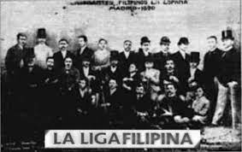

1892: Rizal returns to the Philippines and founds the La Liga Filipina, an organization advocating for Filipino rights and reforms within the Spanish colonial system. However, the group is disbanded shortly after Rizal's arrest.

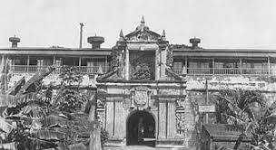

1896: Rizal is arrested by Spanish authorities on charges of rebellion, sedition, and conspiracy. He is imprisoned in Fort Santiago in Manila.

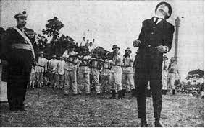

December 30, 1896: José Rizal is executed by firing squad at Bagumbayan, now known as Luneta Park, in Manila. His death ignites the Philippine Revolution against Spanish colonial rule.

The Mercado Family

Francis Mercado **1818-1898**

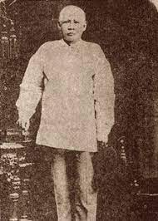

teodora Alonso **1827-1913**

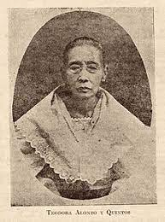

saturnina Mercado **1850-1913**

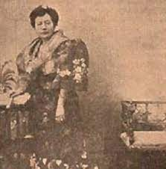

paciano mercado **1851-1930**

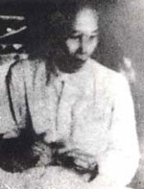

narcisa Mercado **1852-1939**

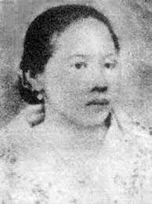

olympia Mercado **1855-1887**

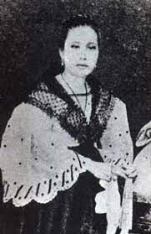

Lucia Mercado **1857-1919**

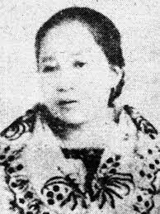

Maria Mercado **1859-1945**

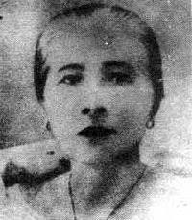

José Protacio Rizal Mercado y Alonso Realonda **1861-1896** 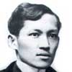

Concepcion Mercado **1862-1865**

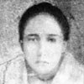

Josefa Mercado **1865-1945**

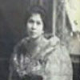

Trinidad Mercado **1868-1951**

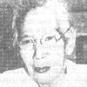

Soledad Mercado **1870-1929**

